**Problem Statement**

**Product Dissection for top leading Platforms**

Welcome to this case study on dissecting and designing products for top leading platforms. In this case study, you will delve into the intriguing world of schema design for a prominent platform of your choice. Your task is to choose a top leading platform, research its features, and meticulously craft a schema design that encapsulates the essence of its functionality. By focusing on key entities, attributes, and relationships, you will gain invaluable insights into how data architecture drives the platform's effectiveness.

**Step 1: Choose a Leading Platform**

Select a leading platform of your choice, which could span various domains such as social media, e-commerce, finance, or any other industry. This choice will form the foundation of your exploration into its schema design.

**Step 2: Research:**

Thoroughly research the platform you have selected. Investigate its core features, functionalities, and user interactions. Identify the top features that define its user experience and contribute significantly to its popularity.

**Step 3: Product Dissection and Real World Problems solved by the platform**

In this step, you will meticulously analyse the platform's standout features and how they provide innovative solutions to real-world challenges. By identifying key functionalities that resonate with users, you'll unravel how the platform effectively addresses problems and enhances user experiences. This dissection will serve as the foundation for understanding how the schema design aligns with the platform's core objectives.

**Step 4: Case Study on the real world problems and approach to solving them**

In this pivotal step, you will expand on the real-world challenges uncovered in Step 3 through a comprehensive case study. Delve into specific instances where users encountered difficulties and showcase how the platform's unique features provided effective solutions. By dissecting the approach taken by the platform to overcome these challenges, you'll gain a deeper appreciation for the platform's user-centric design philosophy and how it shapes the schema design.

**Step 5: Schema Design Based on Top Features**

Based on the features you have identified, craft a schema design that reflects the platform's data structure. Focus on the key entities, attributes, and relationships that underpin the chosen features. Your schema should capture the essence of how the platform organises and utilises its data.

**Step 6: Rationale Behind the Design**

While creating the schema design, consider the rationale behind the platform's choices. Reflect on why certain entities and relationships were chosen and how they align with the platform's goals. This will help you understand the strategic decisions driving the schema's architecture.

**Step 7: Create an ER Diagram**

Utilise tools like the Miro platform or similar applications to create an illustrative Entity-Relationship (ER) diagram. This diagram should vividly depict the entities, attributes, and relationships present within your schema design. The ER diagram will serve as a visual representation of your insights.

**Step 8: Presentation of Findings**

Present your findings in a clear and concise manner. Showcase your understanding of how the schema design impacts the platform's functionality and user experience. Explain how your chosen features are integrated into the schema and how the schema's structure supports the platform's objectives.

**Task Details:**

1. **Answer Submission:** Your submission should include well-structured solutions for all provided questions related to product schema designs.
2. **Video Creation:** Create an informative and engaging video where you thoroughly explain the Case Study.
3. **Depth and Clarity:** Ensure your solutions are detailed and showcase your understanding of product schema design principles. Similarly, in the video, provide clear explanations that are easy to understand for a wide audience.
4. **Creativity Encouraged:** You are welcome to utilise visuals, diagrams, or creative elements to enhance the clarity and impact of your explanations.

**Note:**

1. Duplicate this document and proceed to write your solutions and prepare your video.
2. Include the video link in this document before final submission.

Best of luck in completing this project and showcasing your prowess in dissecting and designing product schema for leading platforms! **For reference, we have also conducted a case study on Instagram, which you can find below. This case study will provide you with valuable insights into how schema design plays a pivotal role in shaping the functionality and success of a prominent platform.**

**Name-** Aryan Singh bhadauria

**Project Name-**  Zomato Product Dissection

**GitHub link-**

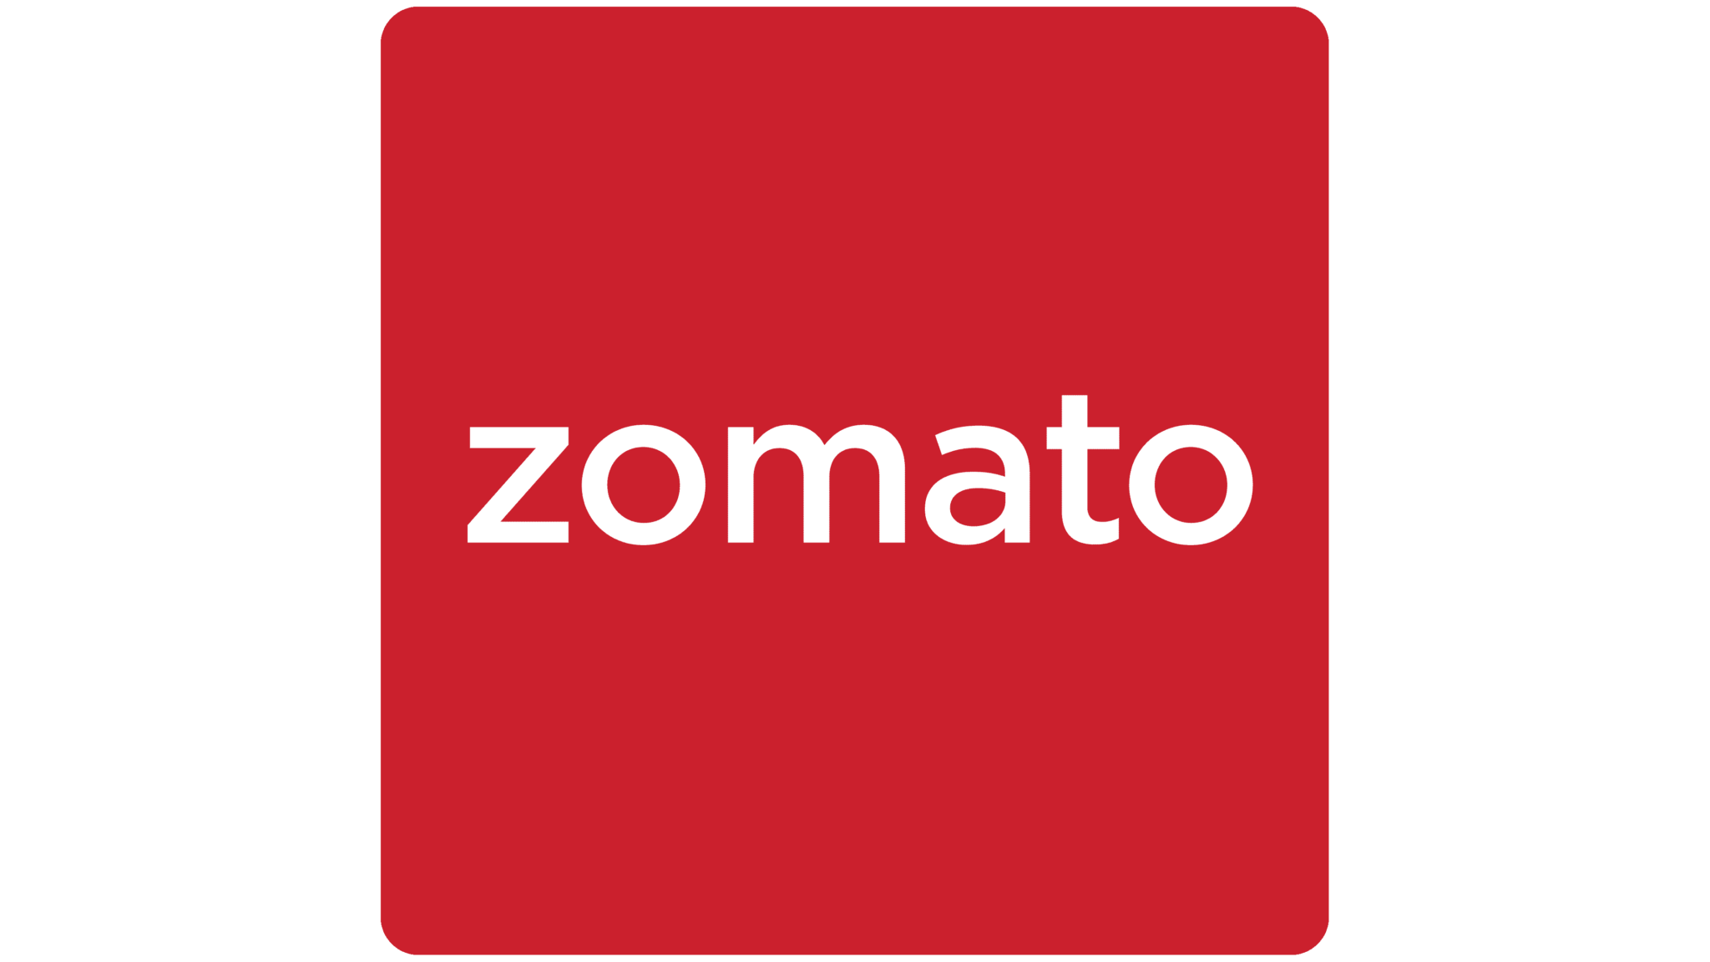

**Product Dissection for Instagram**

### **Company Overview:**

**Zomato** is a leading restaurant search and food delivery platform founded in 2008. It enables users to discover nearby restaurants, read reviews, order food, and make table reservations. With features like live order tracking, digital menus, and verified customer reviews, Zomato enhances the dining experience for millions of users across countries.

### **Product Dissection and Real-World Problems Solved by Instagram:**

Zomato has revolutionized how users discover and enjoy food, addressing a variety of real-world challenges through its platform. At its core, Zomato enables users to search for restaurants based on cuisine, location, cost, and dietary preferences. This solves the common problem of not knowing where to eat or which restaurants meet specific needs. With filters such as "pure veg," "delivery available," "budget-friendly," and "top rated," Zomato simplifies the decision-making process for individuals and groups alike.

One of the key features that solves a major consumer issue is **online food ordering**. Traditionally, ordering food required calling the restaurant, repeating orders, and managing miscommunications. Zomato's platform eliminates these pain points by providing a seamless interface for placing food orders digitally. Users can browse the digital menu, customize items, and place orders with a few clicks—ensuring accuracy, convenience, and minimal interaction. This is particularly valuable for individuals who prefer contactless services or have difficulty speaking over the phone.

Zomato also solves the problem of **uncertainty around food quality and hygiene**. With detailed user reviews, ratings, and photos, the platform provides social proof for restaurants, helping customers make informed decisions. The “Verified” and “Hygiene Rating” badges further instill trust, especially important in the post-pandemic world. Users are more confident in choosing restaurants based on the collective experiences of others, which improves the quality of dining and delivery choices.

Another significant issue tackled by Zomato is the **lack of transparency in delivery**. Through real-time order tracking, users can monitor the status of their orders from restaurant preparation to doorstep delivery. This reduces frustration from delays or miscommunication and provides peace of mind. Notifications for order status updates keep users informed and in control throughout the delivery process.

Furthermore, Zomato addresses the challenge of **meal planning and budgeting** through features like “cost for two,” discounts, loyalty programs, and promo codes. Users can make cost-effective decisions and discover offers that align with their budget. The inclusion of wallet integration and one-click payment also streamlines the checkout process, reducing cart abandonment and ensuring a smooth user experience.

Lastly, Zomato fosters **community engagement** by encouraging users to contribute reviews, ratings, and photos. This not only improves platform content but also enhances user satisfaction by giving them a voice. It helps restaurants receive feedback and improve service, creating a feedback loop beneficial to both consumers and businesses.

## **Case Study: Real-World Problems and Zomato's Innovative Solutions**

Zomato has become a household name in food discovery and delivery, not only because of its extensive reach but also due to its ability to address real-world user challenges through smart, user-centric features. This case study highlights key pain points experienced by users and how Zomato has introduced innovative solutions that directly tackle these challenges.

### **Problem 1: Difficulty Finding Reliable Dining Options**

**Real-World Challenge:** Many users struggle to find reliable restaurants, especially in unfamiliar areas or while traveling. Concerns around hygiene, quality, and taste often deter people from trying new places. Inaccurate or outdated information from search engines or word-of-mouth adds to the confusion.

**Zomato's Solution:** Zomato offers a robust restaurant search and discovery system with user-generated reviews, detailed menus, ratings, images, and cost estimates. Filters allow users to sort by cuisine, location, dietary preference, and user ratings. This solves the problem of uncertainty and provides trustworthy guidance, backed by real customer experiences.

### **Problem 2: Hassle of Ordering Food Over the Phone**

**Real-World Challenge:** Traditionally, food ordering involved calling restaurants, dealing with miscommunication, and waiting without updates. This process was inconvenient, time-consuming, and error-prone—especially during busy hours or in noisy environments.

**Zomato's Solution:** Zomato introduced a digital ordering system that allows users to browse the menu, select items, apply offers, and pay—all within the app. It eliminates phone-based ordering hassles, ensures accurate order placement, and improves user convenience. Additionally, support for multiple payment methods and wallet integration streamlines the checkout process.

### **Problem 3: Uncertainty About Order Status and Delivery Time**

**Real-World Challenge:** One of the biggest frustrations in food delivery is not knowing when the order will arrive or whether it's delayed. Users often feel anxious without real-time updates, and lack of transparency can lead to poor customer experience.

**Zomato's Solution:** Zomato’s **live order tracking** system keeps users updated at every stage—from order confirmation and preparation to dispatch and delivery. Estimated delivery times, courier contact details, and push notifications provide complete transparency, helping users manage expectations and plan accordingly.

### **Problem 4: Lack of Informed Decisions Before Ordering**

**Real-World Challenge:** Users often hesitate to try new dishes or restaurants due to a lack of visual or detailed descriptions. This leads to decision fatigue or dissatisfaction post-purchase, especially when the food doesn’t match expectations.

**Zomato's Solution:** Zomato empowers users with **digital menus, customer photos**, and detailed item descriptions. Visual aids help users anticipate what to expect, while filters like “popular dishes” and “most ordered items” highlight what others are enjoying. This adds confidence to users' choices and improves overall satisfaction.

### **Problem 5: Dietary and Budget Constraints**

**Real-World Challenge:** Some users have dietary restrictions (e.g., vegetarian, Jain food) or limited budgets, making food selection difficult without proper filters or pricing information.

**Zomato's Solution:** Zomato provides powerful filters for food type (e.g., pure veg, vegan), price range, and cuisine. It also displays cost-for-two estimates, offers, and discounts upfront, enabling users to choose options that fit their budget and lifestyle preferences.

### **Conclusion:**

Zomato’s solutions are rooted in real-world challenges faced by modern consumers. Through a combination of intuitive design, community engagement, and technological integration, Zomato has successfully transformed the food discovery and delivery process. Its approach not only enhances the user experience but also establishes a trusted ecosystem for both customers and restaurants. By constantly innovating, Zomato remains a leader in solving real dining dilemmas in urban and semi-urban settings alike.

## **Top Features of Zomato**

Zomato's success as a food discovery and delivery platform lies in its ability to offer a wide range of features tailored to both customers and restaurant partners. Below are the top features that define the Zomato experience and contribute significantly to its popularity:

### **1. Restaurant Search and Discovery**

Zomato allows users to search and discover restaurants based on various filters such as location, cuisine, pricing, ratings, and dietary preferences (e.g., vegetarian). This feature helps users quickly find dining options that match their taste and requirements.

### **2. Online Food Ordering**

Zomato enables users to place food orders directly through its platform. By integrating digital menus, real-time pricing, customization options, and a seamless checkout process, it simplifies ordering and reduces dependency on phone calls or third-party systems.

### **3. Live Order Tracking**

Once an order is placed, Zomato offers real-time tracking of food preparation, dispatch, and delivery. This adds transparency to the process and enhances customer trust by providing updates on estimated delivery time and courier details.

### **4. Customer Reviews and Ratings**

Users can share their experiences by writing reviews and rating restaurants and dishes. This crowdsourced feedback helps other users make informed decisions and provides restaurants with valuable insights for improvement.

### **5. Digital Menu with Photos**

Each restaurant on Zomato features a digital menu complete with item descriptions, prices, and photos. This allows users to visualize what they are ordering, reducing decision fatigue and surprises upon delivery.

### **6. Search Filters and Personalization**

Zomato offers dynamic filters for food type (veg/non-veg), delivery speed, cost, offers, and more. The app also uses algorithms to personalize recommendations based on order history and preferences, enhancing the user experience.

### **7. Table Booking and Dine-In Support**

In select locations, Zomato supports table reservations and dine-in discounts. Users can reserve a table in advance and enjoy special deals on their meals, adding value to in-restaurant experiences.

### **8. Offers, Discounts, and Memberships**

Zomato provides various deals and coupon codes to users. Additionally, Zomato Pro (membership program) offers exclusive discounts and priority delivery, encouraging loyalty and repeat orders.

### **9. Wallet and Multiple Payment Options**

The platform supports a wide variety of payment methods including credit/debit cards, UPI, net banking, and integrated wallets like Zomato Wallet and Paytm. This flexibility simplifies transactions for users.

### **10. User Profiles and Order History**

Users can manage their personal information, view order history, repeat past orders, and update preferences within their account profiles. This improves usability and personal convenience.

## **Schema Description**

The schema design for Zomato encapsulates the core functionalities of the platform, including user management, restaurant discovery, food ordering, and reviews. It consists of several key entities that work together to support seamless interactions between users and restaurants. Each entity is structured to reflect a real-world component of the Zomato application, with attributes capturing essential data and foreign keys establishing relationships.

### **1. User Entity**

The **Users** table stores essential information about each Zomato user. This includes personal details, contact information, and registration date. Each user has a unique UserID, which acts as a primary key and links to other activities such as orders and reviews.

**Attributes:**

* **UserID (Primary Key):** Unique identifier for each user
* **Username:** Chosen display name
* **Email:** Registered email address
* **FullName:** User’s full name
* **Address:** Optional delivery address
* **RegistrationDate:** Date the user joined the platform

### **2. Restaurant Entity**

The **Restaurants** table represents all restaurants listed on the Zomato platform. It includes details relevant to users, such as location, cuisine type, pricing, and ratings. Each restaurant is uniquely identified by **RestaurantID**.

**Attributes:**

* **RestaurantID (Primary Key)**
* **Name:** Name of the restaurant
* **Location:** Address or city
* **Cuisine:** Type(s) of cuisine served
* **IsVegOnly:** Boolean indicating if the restaurant serves only vegetarian food
* **AvgCostForTwo:** Average price for two people
* **Rating:** Average user rating

### **3. MenuItems Entity**

The **MenuItems** table lists all available dishes/items offered by restaurants. Each item is linked to a restaurant and includes a name, price, and a flag for vegetarian options.

**Attributes:**

* **ItemID (Primary Key)**
* **RestaurantID (Foreign Key):** Links to the **Restaurants** table
* **ItemName:** Name of the dish
* **Price:** Price of the item
* **IsVeg:** Boolean indicating vegetarian status

### **4. Orders Entity**

The **Orders** table captures the order activity initiated by users. It records the user and restaurant involved, the date/time, total bill, and order status.

**Attributes:**

* **OrderID (Primary Key)**
* **UserID (Foreign Key):** The user who placed the order
* **RestaurantID (Foreign Key):** The restaurant from which the order was placed
* **OrderDate:** Timestamp of when the order was placed
* **TotalAmount:** Total cost of the order
* **Status:** Current order status (e.g., Placed, In Progress, Delivered)

### **5. OrderItems Entity**

This table acts as a junction between **Orders** and **MenuItems**, detailing the specific items within each order. It supports the many-to-many relationship between orders and menu items.

**Attributes:**

* **OrderItemID (Primary Key)**
* **OrderID (Foreign Key):** The order to which the item belongs
* **ItemID (Foreign Key):** The item being ordered
* **Quantity:** Number of units ordered

### **6. Reviews Entity**

The **Reviews** table allows users to leave feedback on restaurants. Each review is tied to both a user and a restaurant, and includes a rating and optional comment.

**Attributes:**

* **ReviewID (Primary Key)**
* **UserID (Foreign Key):** The user giving the review
* **RestaurantID (Foreign Key):** The restaurant being reviewed
* **Rating:** A score from 1 to 5
* **Comment:** Optional text feedback
* **ReviewDate:** Date and time of review

## 

## 

## **Relationships Summary**

* **Users ↔ Orders**: One user can place many orders.
* **Restaurants ↔ Orders**: One restaurant can receive many orders.
* **Orders ↔ MenuItems**: A many-to-many relationship handled via **OrderItems.**
* **Users ↔ Reviews**: A user can leave many reviews.
* **Restaurants ↔ Reviews**: A restaurant can receive many reviews.
* **Restaurants ↔ MenuItems**: One restaurant offers many menu items.

**ER Diagram:**

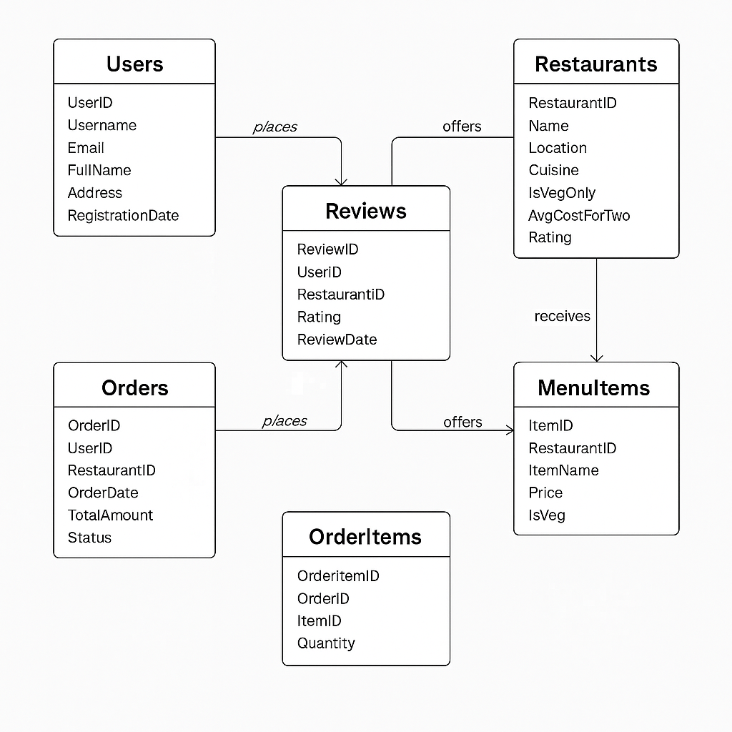

### 

### 

### **Conclusion**

The ER Diagram effectively illustrates the underlying data structure that powers Zomato’s key functionalities—restaurant discovery, menu browsing, order placement, and user feedback. Each entity, such as Users, Restaurants, Orders, MenuItems, and Reviews, is clearly defined and linked through well-structured relationships.

By capturing real-world interactions like “users place orders,” “restaurants offer menu items,” and “users leave reviews,” the ER model demonstrates how Zomato manages data efficiently and at scale. The diagram not only supports a seamless user experience but also highlights the relational integrity and normalization principles that make the system robust, scalable, and easy to maintain.

This schema lays a solid foundation for building a functional and optimized food delivery application, reflecting Zomato’s actual data handling approach.